**Project Proposal**

1. **Project Name: -** Bhartiya Kisan Portal (Krishak)
2. **Department and University Name: -** Computer Science and Engineering, Madan Mohan Malaviya University of Technology, Gorakhpur U.P. 273010.
3. **Keyword:** - Kisan, Bhartiya Kisan, Krishak, E-commerce, Online Kisan Portal
4. **Introduction: -** Farmers are the backbone of our society. They are the ones who provide us all the food that we eat. As a result, the entire population of the country depends on the farmers, yet they are exploited most.

Nowadays there is an alarming increase in the suicide rate among Indian farmers. If we took a close eye on the problem, we will see that there are two main causes of this problem, first is the crop failure due to climate change, pests and not following the advanced farming method. The second cause of the problem is not getting the proper price of their crops due to the large margin of profit taken by the middleman through which they sell their crops.

Our final year project, Bhartiya Kisan Web Portal, is an application that is dedicated to the farmers, which overcome both the above problem.

The solution to crop failure can be overcome if somehow, we know, what will be the climate condition in upcoming seasons, and which crops they should grow. Henceforth our Bhartiya Kisan Portal will provide them with upcoming climate conditions to grow their crops using weather forecasting with the help of Machine Learning.

The solution to providing them the fair price can be done by connecting farmers directly to consumers through a Bhartiya Kisan portal eliminating the large margin of profit taken by middleman.

1. **Objective: -** The main aim of this project is to provide an integrated online platform and to provide farmers in ease of farming and -

* The relevant price for their crops, by connecting them with the end user directly on our platform.
* Weather forecasting data to minimize the risk of crop failure, using machine learning algorithms.
* Discussion platform where they can interact with other farmers to share the methodology, they have used to grow crops in a better way.
* Payment gateway will help them to make caseless transactions and connect them to digital India.
* End consumers will also get better crops at a reasonable price.

1. **Practical Utility: -** The Bhartiya Web Portal requires only mobile phones and the internet to access its services. In the modern scenario, everyone owns a mobile phone and the Government of India is also connecting villages through Digital India, which aims to connect all the 6,25,000 villages by December 2019. So, there is no constraint to the user to use it.

The mobile data is a lot cheaper, and a large population of the country is coming online. Digitization in the agriculture sector is advancing, hence connecting farmers to digital India will not only increase their prosperity but strengthen the backbone of the country.

Providing farmers with a user-friendly interface to sell their crops is the need of the hour. Bhartiya Web Portal will make sure that authentic user is present on the site to minimize frauds. Payment Gateway will help with the easy flow of money. To minimize the cost of transportation filters according to distance and crops will be provided.

1. **Methodology: -** The project is built on the architecture of MVC (Model View Controller). Technologies are being selected to make project scalable and maintainable after going through the latest developments.

The Web-App will be divided into three parts-

* Farmer Panel
* Consumer Panel
* Admin Panel

Farmer Panel will include the features of registering them with the platform, recommendation system to update them about crops to grow, crops in demand and their selling price.

Consumer Panel will include the features of registration, showing them about the crops and various filtering options.

1. **Application Architecture: -**

**Fig.1 – Client/Server Architecture**

**Fig.2 – Application Architecture**

**Fig.3- Use Case Diagram**

1. 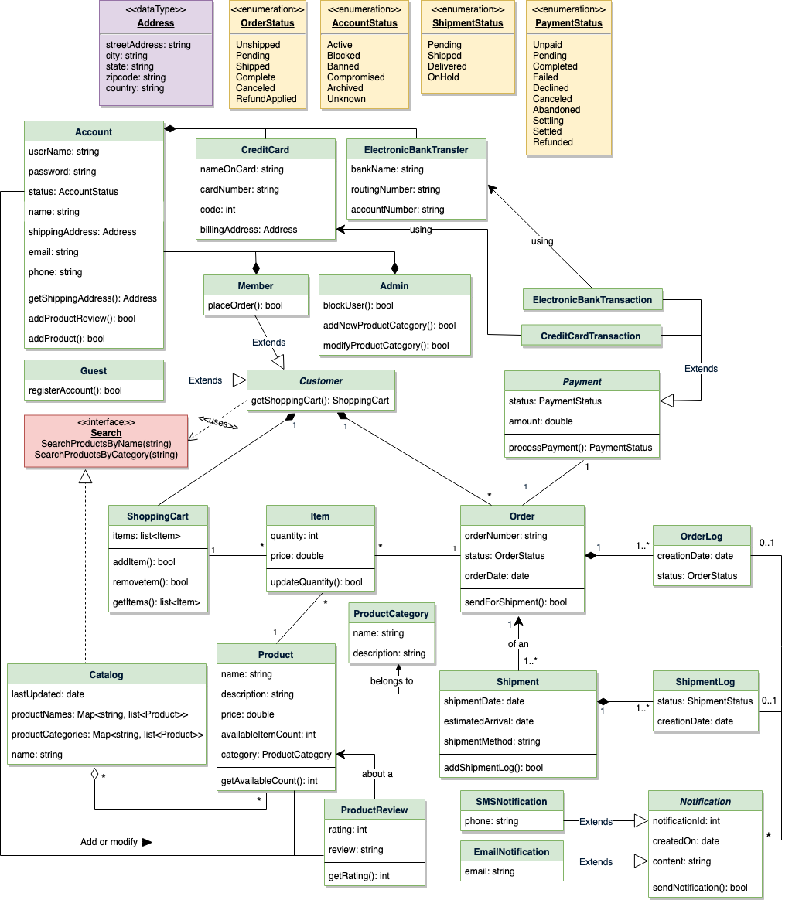**Object Relation Mapping: -**

**Fig.4 - Object Relation Mapping**

1. **Is this project related to any regional problem?**

Yes,

The project solves the major problem of poverty prevailing among farmers. The project aims at providing the fair price to the farmers which will help them to uplift. Besides the farmers can move from the traditional way of farming to the more advanced method of farming, which will help them to produce better crops, and get good profit. The crops are attacked by the diseases and they are unaware of the processes to follow to get rid of it, so connecting them with fellow farmers will help them know about the effective way to get rid of it.

The farmers of India are very much dependent on the monsoon for irrigation, and due to irregularity in monsoon the crop suffers a lot, so with the help of weather forecasting this will help them to know in advance, to grow the crops which require less water. The weather forecasting will also help them to know about other climate change and know in advance which crops to grow.

1. **Commercial application/utility if any & scope of future work**

Although the access to the web application will be free to users but a very small amount of money will be charged from the farmers on the transaction made. As it will scale the revenue earned can be used in educating them by creating videos about the farming methods and organizing meetup whose access charge will be charged from them. As the project aim at betterment of farmers which belongs to a poor background so it will be charged in such a way that it is affordable, so to generate more revenue advertisement will be shown on the platform.

1. **Result and Conclusion**

Bhartiya Kisan Portal will provide farmers with the solution of connectivity problem with the consumers. It also gives them information about the advanced method of farming provided on the platform. Overall it will help the farmers to get out of poverty by connecting them with present day technology.